Purpose

Results & Discussion

44.4% of the 54 students we surveyed spent over
₹1500 last semester on textbooks, printed notes and photocopies. After exams, 31.5% leave old material in a cupboard or throw it away, while juniors search for affordable material without a trusted source.
Campus Xchange connects seniors and juniors on one verified campus marketplace, so study material is reused instead of wasted.
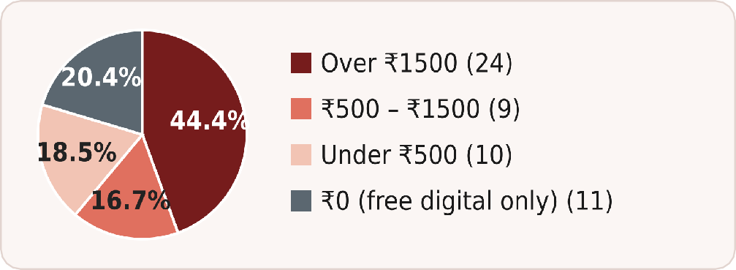
Figure 1: Spend on books, notes and copies last semester (n = 54).

Project Code - [PROJECT CODE]

Sr. No. | Name | Affiliation | Project Mentor
1 | Aditya Sarvesh Pandey | SOCCA (B.Sc. CS-IT) | Mahesh Thakor
2 | Ayush Dangi | SOCCA (B.Sc. CS-IT) | Mahesh Thakor
3 | Pranshu Jani | SOCCA (B.Sc. CS-IT) | Mahesh Thakor
4 | Nelson Dev Gajjar | SOCCA (B.Sc. CS-IT) | Mahesh Thakor

- 68.5% already pass on old books (42.6% give them free, 25.9% sell); 31.5% leave them in a cupboard or throw them away.
- 83.3% would sell old material or buy used material at low prices.

CAMPUS XCHANGE: A VERIFIED CAMPUS MARKETPLACE FOR TEXTBOOKS AND NOTES
- 37.0% fear paying before seeing the notes, the top barrier. Verified profiles, in-app chat and ratings address it.
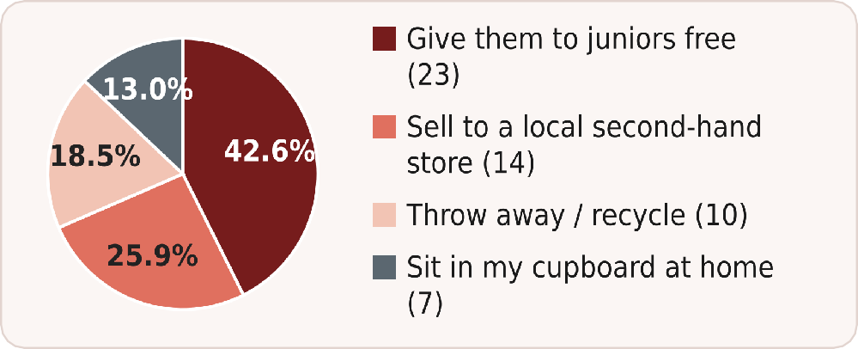
Figure 7: What students do with old books and notes after the semester (n = 54).

Abstract

Methodology

Conclusion & Future Scope

Campus Xchange is a peer-to-peer web app where verified college students buy, sell and swap used textbooks, lab manuals and handwritten notes. Listings are organised by course and semester. Buyers send a request, chat inside the app, meet at a public campus spot and rate each other.
Demand was checked with a survey of 54 students, mostly undergraduates.

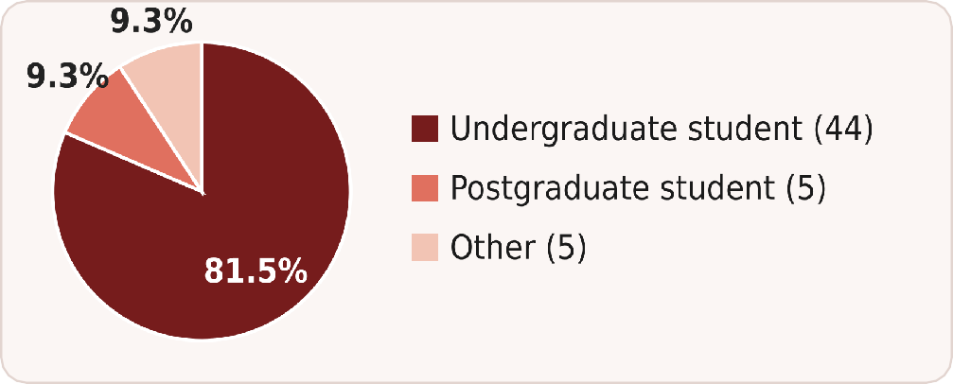
Figure 2: Who answered the survey (n = 54).
The project followed a design-first method: requirement analysis from a student survey, problem definition, flow design, user-interface design and prototype development.
- Survey: Google Forms, 54 responses (81.5% undergraduates)
- Prototype: responsive web app with a semester-wise catalog, search, requests and an admin panel; stack: [FRAMEWORK] + [BACKEND]
- Trust features: college-email sign-up, in-app chat, ratings and public meetup spots
- Survey-driven design: 37.0% distrust paying before seeing notes, so buyers request, chat and inspect before any payment

Rate each other

Sign up with college email

List an item

Browse by course

Send request

Chat

Meet on campus

Figure 3: Campus Xchange flow from sign-up to a completed exchange.
Campus Xchange indicates that a verified, course-based marketplace can make reuse of study material easier and cheaper for students. Survey results show strong demand and a clear trust gap that verification and ratings address.
Future scope: user testing and a pilot in one department, wishlist alerts and swap matching, then extension to the whole college.
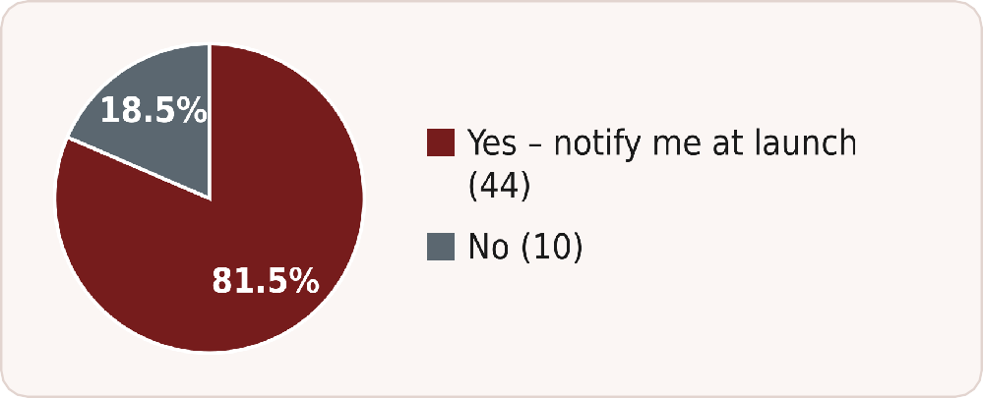
Figure 8: Students who want to be notified if the platform launches at their college (n = 54).

Literature Survey

Data Analysis (Data / Tables / Graphs / Images)

References (IEEE Format)

Existing options such as OLX, WhatsApp and Telegram groups, and local second-hand shops are not organised by course, do not prove that a seller is a student, and expose personal phone numbers.
Research on peer-to-peer markets highlights trust and reputation as key drivers [1], [2]. Campus Xchange applies these ideas inside a single campus.

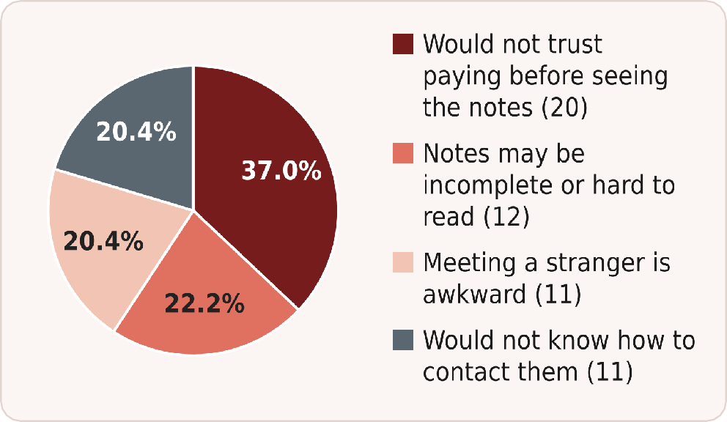
Figure 4: Biggest concern when buying notes from an unknown senior (n = 54).

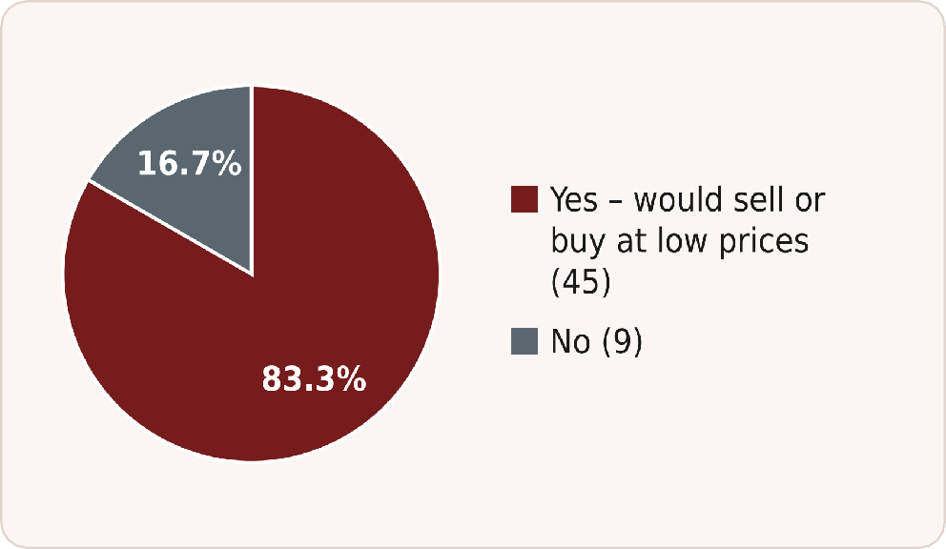
Figure 5: Willingness to sell old material or buy used material at low prices (n = 54).
- E. Ert, A. Fleischer and N. Magen, “Trust and reputation in the sharing economy: The role of personal photos in Airbnb,” Tourism Management, vol. 55, pp. 62–73, 2016.
- P. Resnick, R. Zeckhauser, J. Swanson and K. Lockwood, “The value of reputation on eBay: A controlled experiment,” Experimental Economics, vol. 9, no. 2, pp. 79–101, 2006.

SDGs Covered
SDG 4 · SDG 10 · SDG 11 · SDG 12 (full colour)

Table 1: Comparison of existing options with Campus Xchange.
 | Course-wise listing | Verified student seller | Phone number kept private
OLX | ✗ | ✗ | ✗
WhatsApp / Telegram groups | ✗ | ✗ | ✗
Local second-hand shops | ✗ | ✗ | ✗
Campus Xchange | ✓ | ✓ | ✓

Prototype features
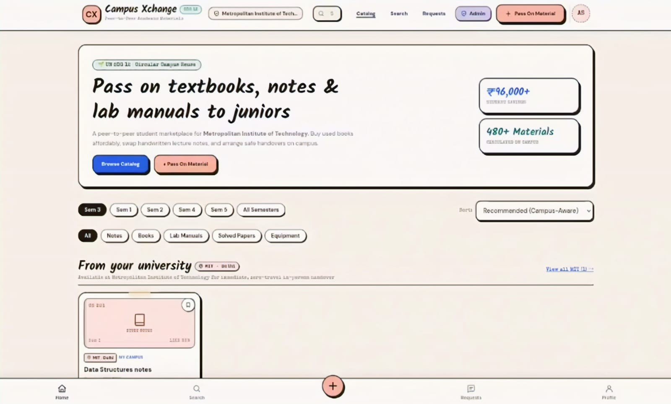










  - Catalog filtered by semester (Sem 1–5)






  - Notes, Books, Lab Manuals, Solved Papers, Equipment
  - Campus-aware recommended sorting


  - Search, requests and admin panel

  - “Pass On Material” button to list an item



Figure 6: Campus Xchange home page (prototype).

